General Comments:

* Really liked
  + the flow of the story, the sense of leadership and ownership over the decisions and the lives of the men
  + narrative is kind of easy to follow: rationale for each of the choice seems logical.
* Can be improved:
  + More ownership over the number of men – the number of men can denote whether some options are no longer available etc. Right now, the brackets with the number of men still alive does not impact me as much/a point that I think is not contributing to the narrative at all (can even be omitted) and I only noticed it when I played the game the third time.
  + The word choices are sometimes too casual for a war game and is very jarring.

Detailed Comments:

* The sounds need to be standardized: either bold or italicize them!
  + 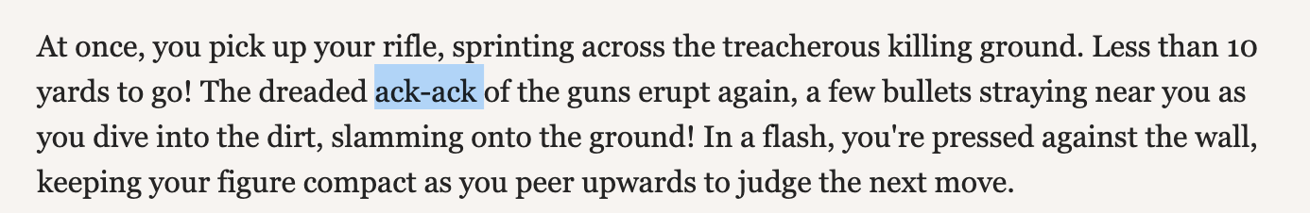
  + Is this a sound? Even mimicking of a sound.
  + Suggestion: Important sounds (eg. The starting Rat-tat-tat-tat and the Bang Bang can be kept bold but mimicking sound that holds not much importance to the narrative (like the above image) can be italicized. I found myself going back to reread that part to make sure I was understanding it as a sound and not as a word that I simply don’t understand.
* The “Moreover” here seems to break the flow of the imagery and the “grisly ends” seem to overkill the imagery.
  + 
  + Suggestion: “You also never know if the three teens radioed for help before meeting their grisly ends” OR “You also never know if the three teens radioed for help before their deaths”
* The options are not very clearly described by the narrative here: had to go back, relook and reread the narrative a number of times
  + 
  + Especially for the “junction”: use the same terms. Within the narrative, you used “crossroads”, if it was a less lengthy narrative, it would have been pretty clear/obvious, but because there is so many details of each other location, it has to be made even more distinct.
* Explain what the RPG is earlier/when it is more needed:
  + 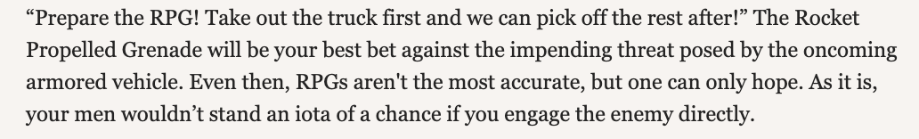
  + Might have an explanation of what it is in the first narrative, but with so many acronyms and technical terms, the layman reader might not immediately pick it up or remember it.
  +  (explanation in the introduction narrative, but it is too far from the option which I was presented with RPG)
  + Only give an explanation after the option is selected.
* Possibly give a “reconsider” option: adds to the level of doubt
  + 
  + 
  + If not there does not seem to be a reason for these discourse?
* The “as they say” is very unnecessary. Who says? Is it important to the narrative?
  + 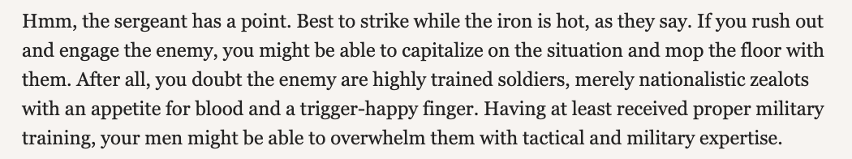
* Flow between describing of the options can be improved. Currently seem very haphazard, it is either list or don’t list. This current flow makes it seem very unclear – it bounces between listing and being a part of the narration, which therefore makes it quite difficult for the reader to conceptualize
  + 
  + “Then again, you could just” gives a very dismissive tone which is very jarring and contrasts the setting of being in war.
* The “All” seems very unnecessary
  + 
* Reverse the phrasing of this:
  + 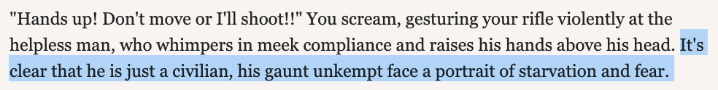
* I am not too sure if this is a coding thing, but is it possible to make this clearer?
  + 
  + Like Stat Check: Charm = +10?
* A little too dramatic? I am confused by the escalation
  + 